Lakeview Farm, 1966.
This is a personal post. The photo is of my parent's farm as it existed in 1966. The photo was probably taken on an August afternoon. My seven siblings and I grew up on this farm.
We loved it.
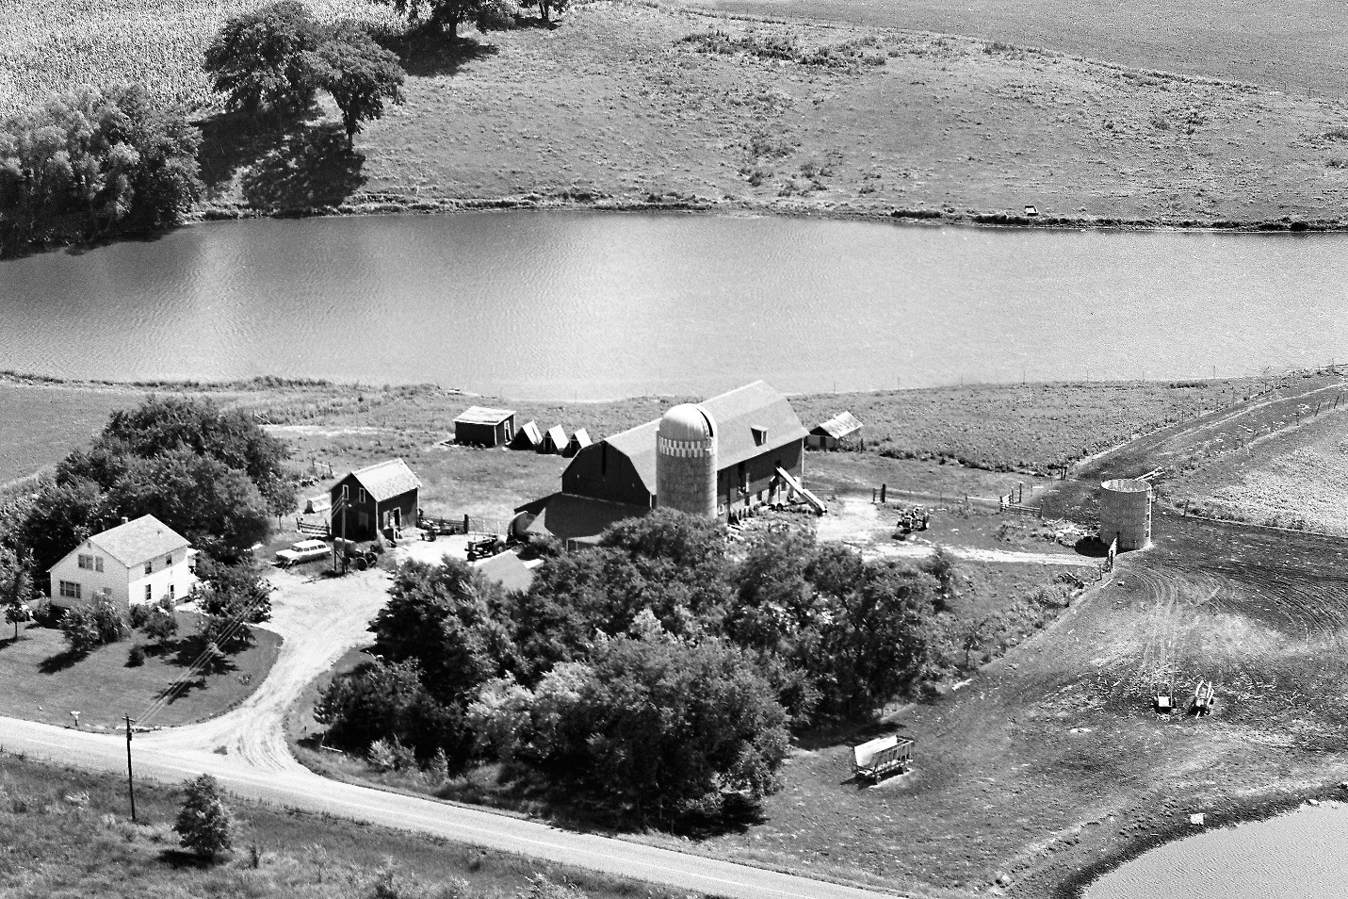
Ma and Pa named their farm, Lakeview Farm. We raised hogs and chickens and sheep from time to time but mostly we raised great Jersey milking cows. My brothers and sisters and I won many blue and many grand champion ribbons with our cattle at county and state fairs.
Recently, sister Pat came across a company that is selling old farmstead photos. So, we bought the electronic copy. Farmstead photos were taken from the window of a small airplane. Then salesmen traveled the countryside selling them to proud farmers. You could get them "in color" for extra money. They said that farm wives in Iowa would paint them according to the colors you gave the salesman.
Our farm was in Otsego, Minnesota, which is between Rogers and Elk River. Between the Mississippi and the Crow Rivers.
Two gravel roads passed by the farm. The east-west one is now a paved County Road 38. The north-south road is a very busy four lane highway, Minnesota 101.
We milked 48 fine Jersey cows in the big barn. We built the barn in 1957 by adding to an existing barn.
We built the white house in 1952. The smaller, house like structure was in fact the "old house". The old house was moved across the farm yard on rolling logs. When the time came to move it, every farmer in the neighborhood showed up with his little 1950 size tractor. Those men and tractors pulled and dug and broke chains for two days to move the house. It was grand fun for a farm boy. Now, most any field tractor could drag that little building.
On the roof of the big barn, you can see a small dormer. The dormer roof made a perfect angle for a recliner. Ma loved to read. She bought the library of a one-room school when it closed. The library was predominately classic books. I stashed books in the hay mow to read when I was caught up on chores. The roof of the dormer was a perfect, private reading room. I read The Odyssey, The Song of Roland and many other fantastic books in that sunny, delightful place above the farm.
The buildings are all gone. If you pass by you will see "Anoka Equine Veterinary Clinic" at the approximate location of the house and barn.
The small pond to the lower right was full of frogs, tadpoles and mud turtles. Now, it is under a sweep of the cloverleaf.
Beyond the long lake were the rolling hills of the farm. The fields were fertile but so steep that it took special skill to stack a wagon load of hay. Those fields have all been leveled. I mean, really leveled. Two enormous distribution buildings cover the entire farm beyond the lake.
Lakeview Farm is just memories now, but it was a wonderful time and a wonderful place to be a farm kid. Tom
P.S. Brother Jim has one of the three "A" frame sow houses at his home. Jim repurposed it into a smoke house. The Farmall B tractor that you see under the power pole is parked in my tractor shed. It runs well.
4/3/2017

