Snake River Farm Animals on a 50 below Morning.
Our thermometer read -35 at sun-up. Minneapolis claimed a -51 windchill. It is safe to say we were between -50 and -60 windchill.
I took some snap shots of the animals when I did the morning chores. Not much had to be done actually. I had put out plenty of feed for all the flocks and herds yesterday. I did want to check on the creatures, however.
The sheep in their heavy wool coats seemed as comfortable as they could be. They were out of their open shed and eating hay early.
Gail has five ewes and a visiting ram. How many can you count in the first photo? They are eating breakfast, using the hay bale as a wind break and catching some warm rays.

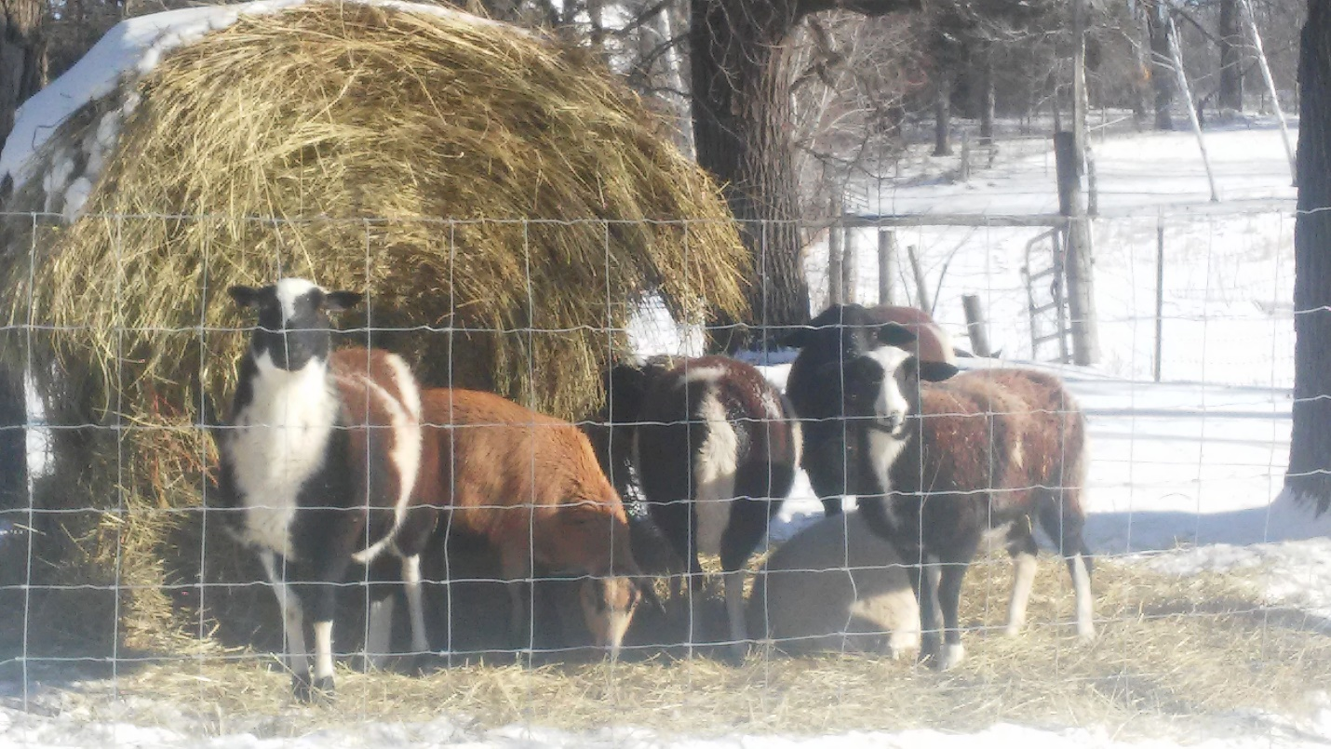

The horses are well adapted to the weather. They have an open shed also but the biggest factors are that they are always outside. That allows their bodies to grow an excellent coat. Horses often do better than cattle in bitter cold weather. Like sheep and cattle, horses need a constant supply of palatable forage to produce necessary heat in their guts. In the photo you can see the horses eating hay while standing as obliquely as possible to the sun. That maximizes solar warming of their coats.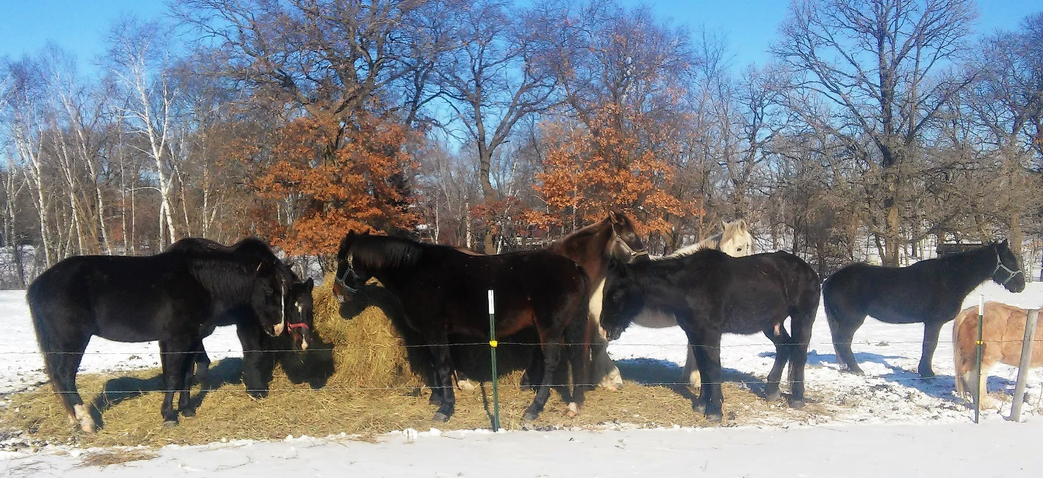

The cattle are great producers of heat in their complex stomachs. Body warming heat is a major by-product of their digestive process.
The cattle herd of about 20 animals got out of their shed early to fill their bellies with hay. By the time I went out for a photo, they full stomachs and were lined up for solar warming. They are close to the road, because the low ditch breaks the wind for them. Even so, they show signs of being chilly. They will do fine but they are not as comfortable as the other animals.
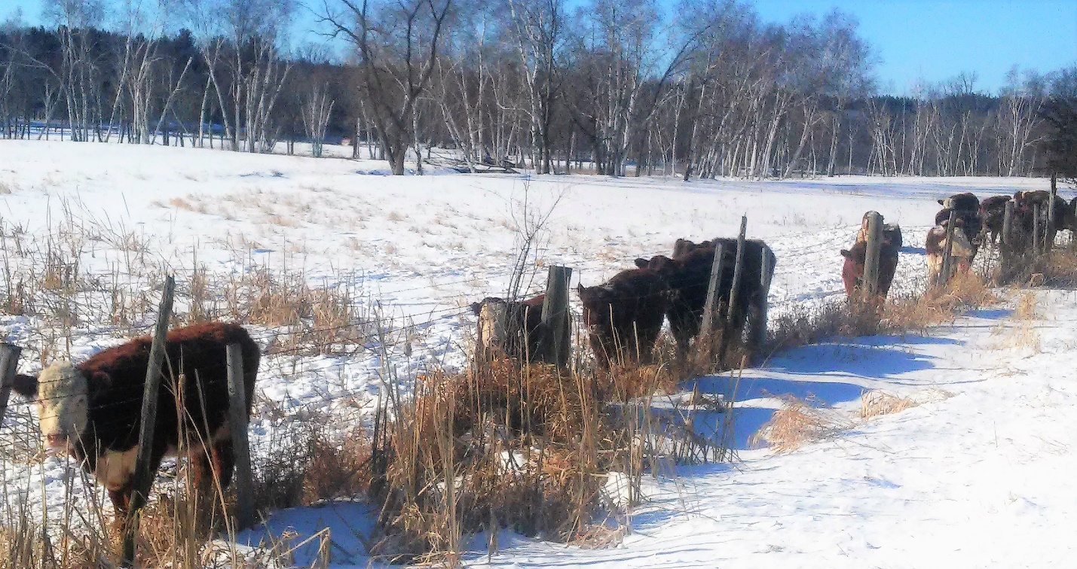

Gail’s laying hens normally get outside each day. A hen and the roaster snuck by me as I opened the door. The coup has a couple of heat lamps to keep the temperature above toe and comb freezing temperature. Chickens are Mediterranean creatures. Not designed for deep cold.
I shushed the two birds back in on the assumption they did not know what they were headed into.

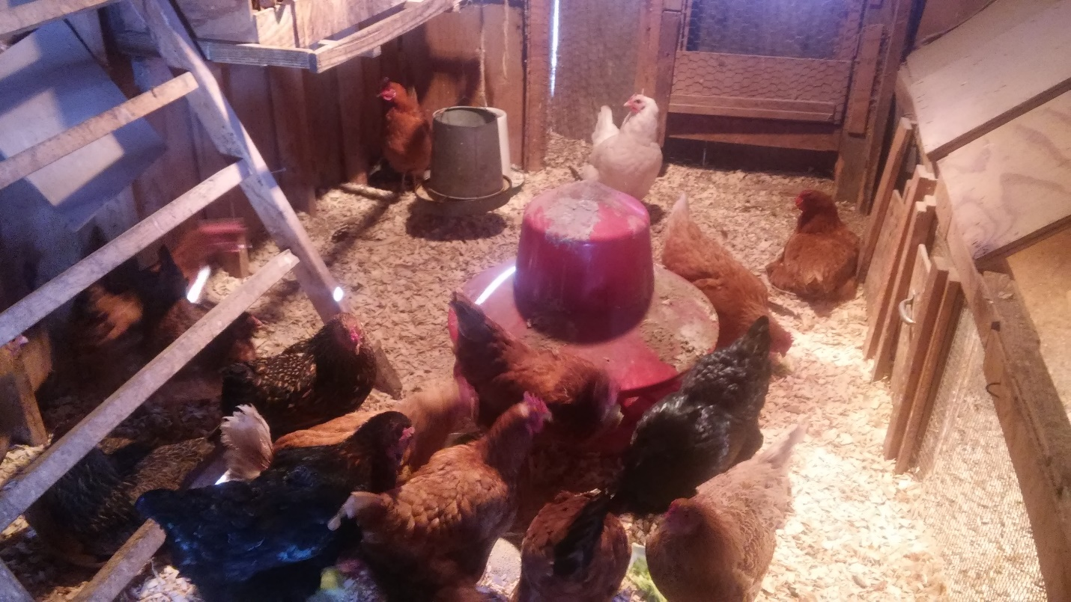

Only three eggs today. No surprise there. There might be a couple more later.
Two of the eggs in the photo were still warm, under a hen. The third egg which is frozen and cracked was uncovered. It is not particularly unusual for eggs to freeze. Normally the expansion that cracks the shell does not break the flexible membrane that lines the shell.
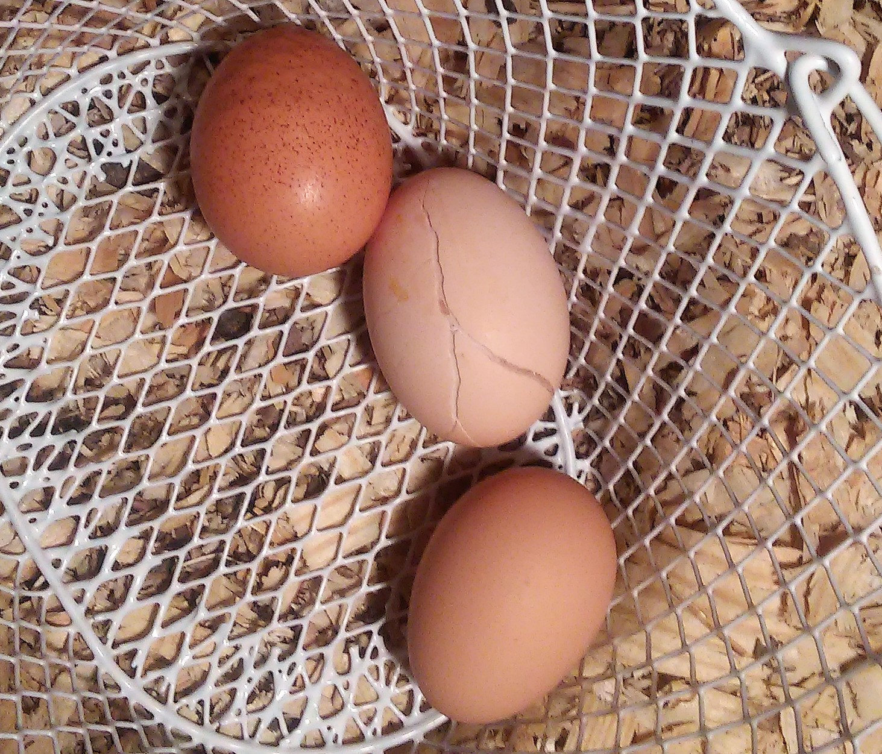
In the next photo, you can see that when the egg warms up, the crack closes.
An egg like that could not go into commerce. It would too much of a salmonella risk to the public. There is very little or no risk to farmers whose immune systems have been exposed for a lifetime to farm animals.
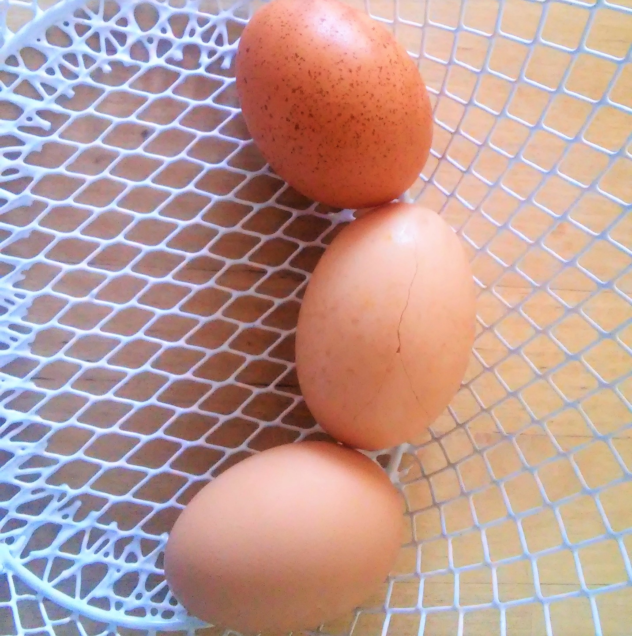

The last photo is of the bison herd in a piece of woodland that we are restoring to savanna. I did not get to the bison until after 10 a.m. but they were so comfy that they were still in bed.
I took the photo from afar because I did not want to make them stir.
Bison are wonderfully adapted to bitter northern cold.
They have good forage available but they are not in a hurry to get to it.
Besides all the advantages of a fantastic coat and a ruminant’s heat producing gut, their metabolism slows down in the winter.
They could not be more relaxed or more comfortable. This is their element. This their time.
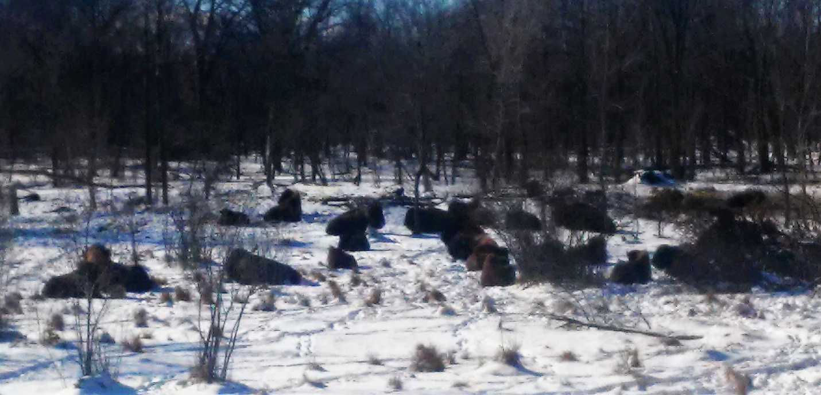
Best regards.
Tom

